# An analysis of global Covid-19 data

Author: Rafał Klinowski

## Used Dataset

The dataset used is the Global Covid-19 Data by Valtteri Kurkela, downloaded from [https://www.kaggle.com/datasets/thedevastator/global-covid-19-data on 9.12.2023](https://www.kaggle.com/datasets/thedevastator/global-covid-19-data%20on%209.12.2023).

## Initial data exploration

Firstly, the data was loaded in RapidMiner and stored as a dataset.

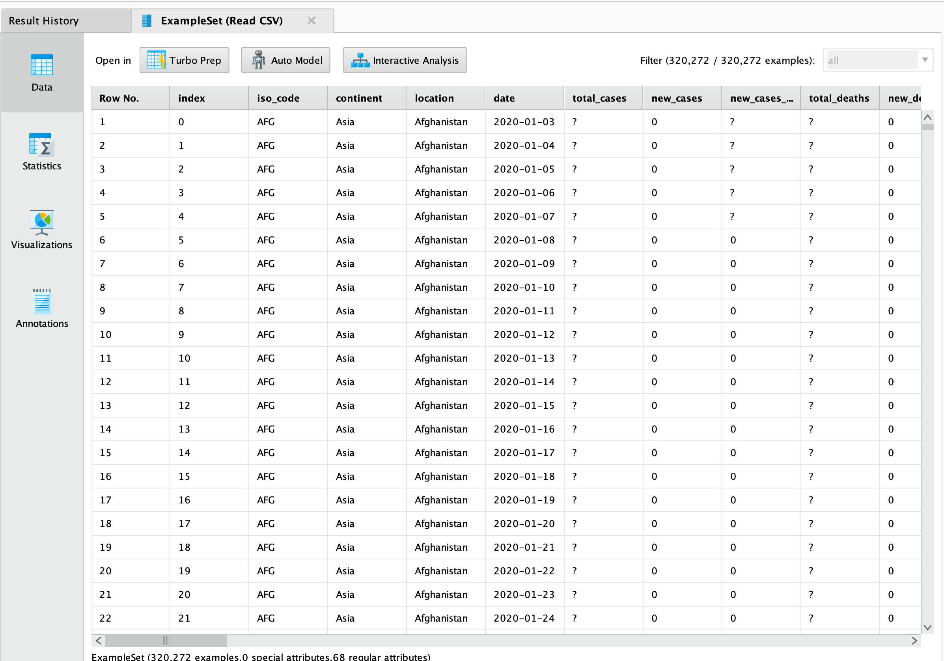

Figure 1. First few rows of the dataset.

We can see some information about the data, such as:

* There are a total of 320271 data rows with 68 attributes
* The data was collected between 1-01-2020 and 25-06-2023 (the collection was non-uniform – some days have more data than others)
* There are multiple missing values – some columns have as many as 310581 (97%) missing values

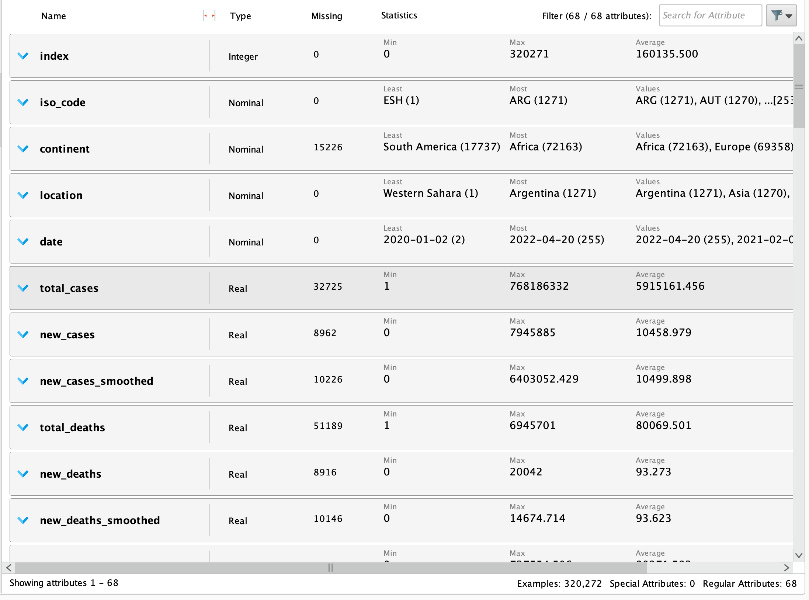

Figure 2. Some statistics about several attributes from the dataset.

## Handling missing values

The first step is to remove all attributes with more than 90% missing values. These attributes are not documented well enough to be considered for this project. Some other attributes (such as “icu_patients_per_million”) can still be useful if analyzed properly, despite about 88% missing values. Some attributes have missing values likely because the data started to be collected later on (for example the “new_vaccinations” attribute – the vaccine was not yet available when the data started being collected in 2020).

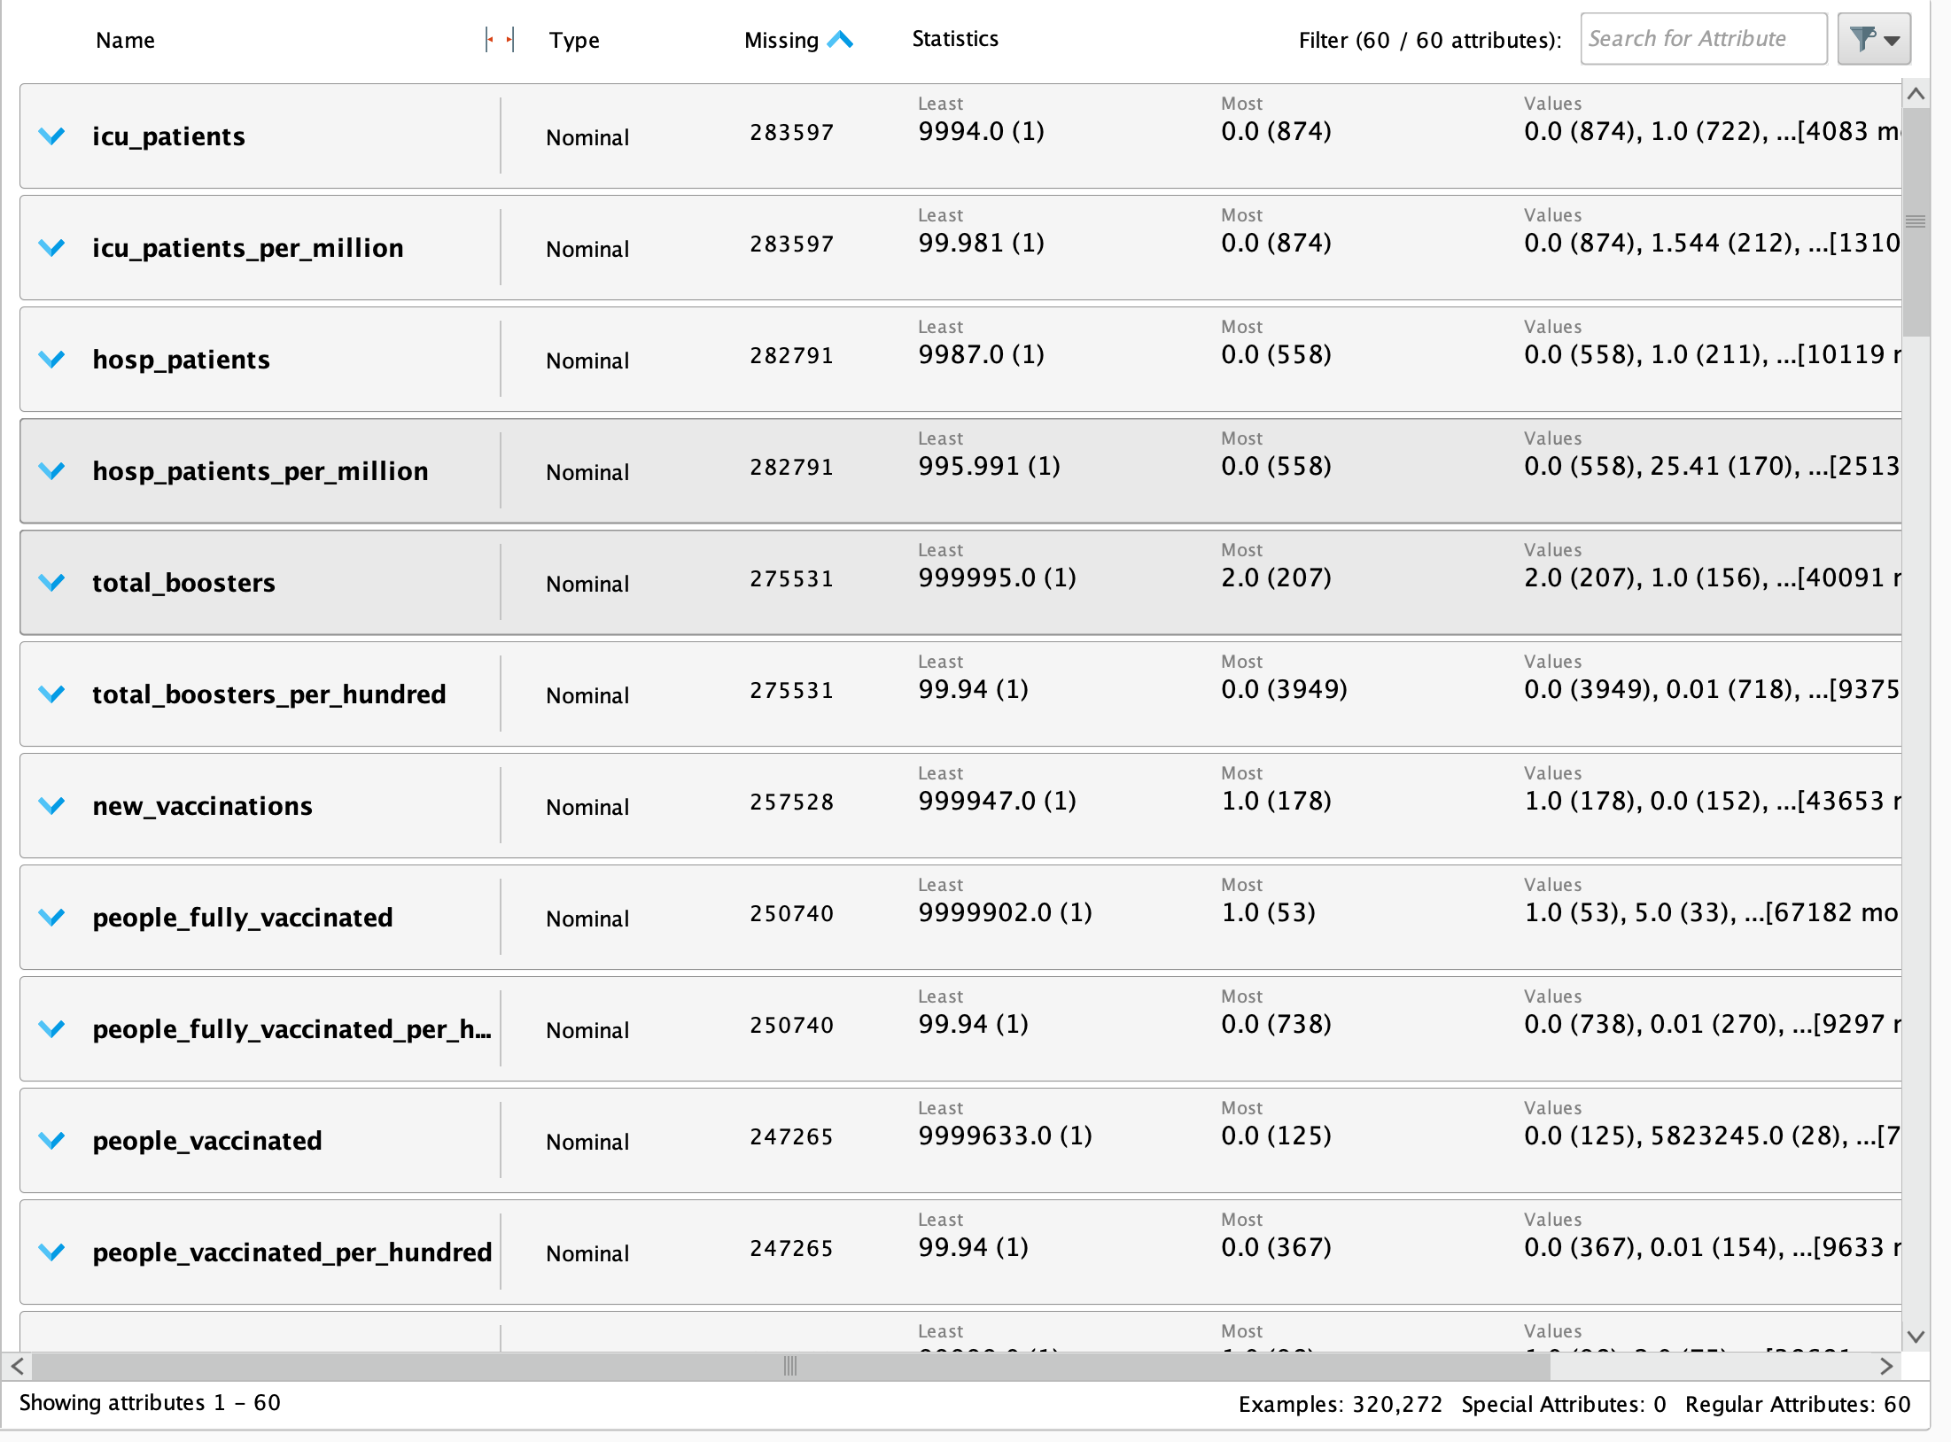

Figure 3. The results after the first step of handling missing values.

For the statistics attributes such as “new deaths” or “new cases”, we will assume they are equal to 0 on a given date if there is no given value.

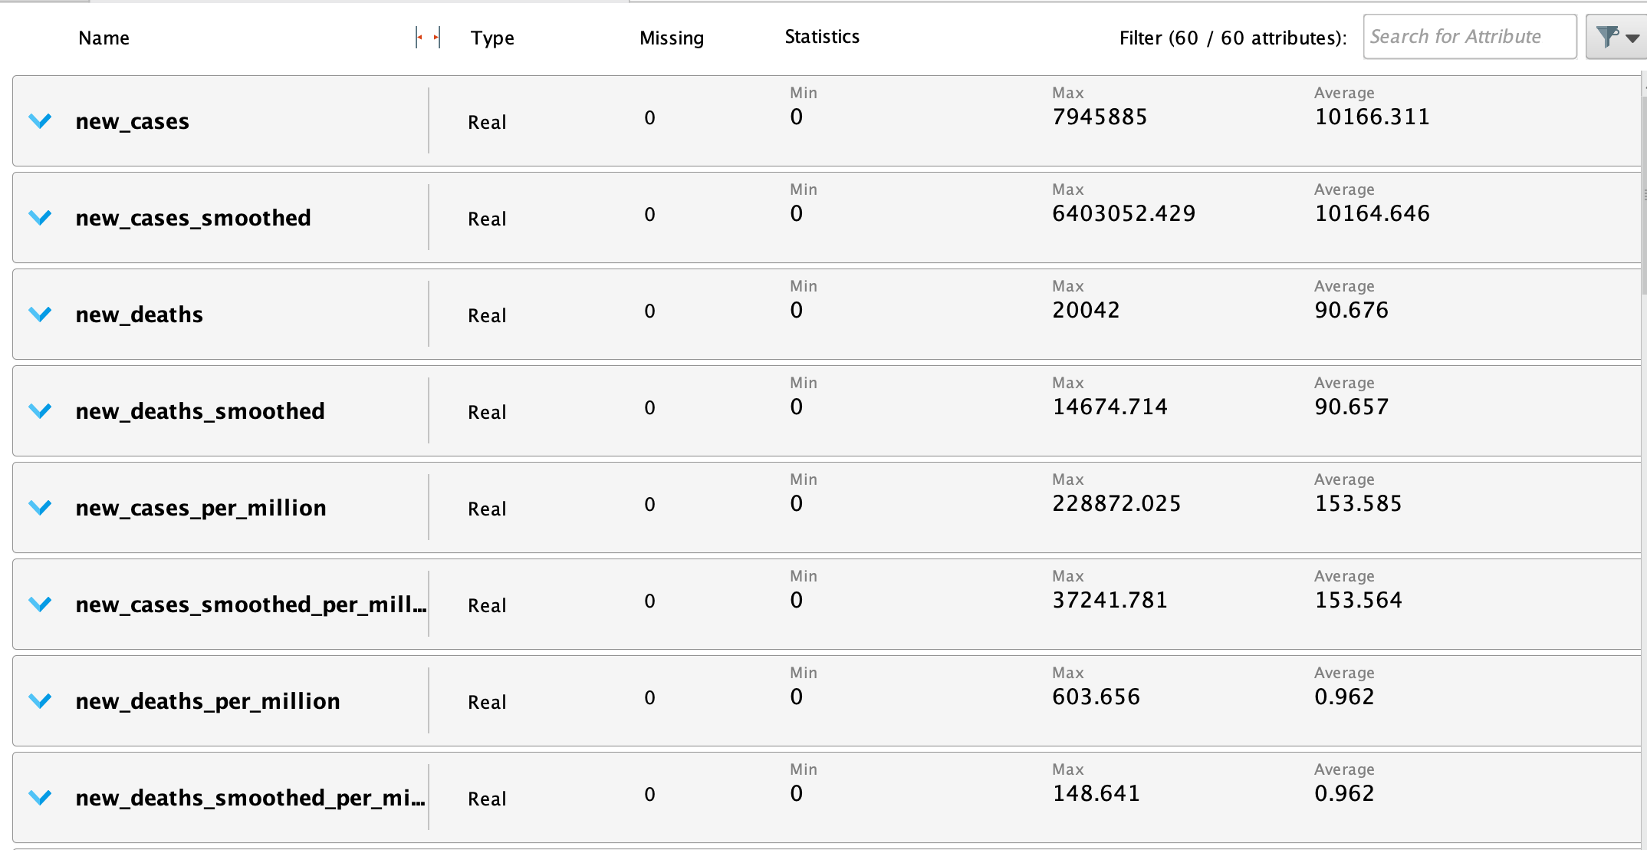

Figure 4. Several attributes after replacing their missing values with zeroes (where it made sense).

An interesting note is that there are missing values for the Continent attribute, but no missing values for the Location or ISO_code attributes. Therefore, the missing values for Continents could be deducted from the country names.

To fix this, we use the Countries-Continents dataset from <https://github.com/dbouquin/IS_608/blob/master/NanosatDB_munging/Countries-Continents.csv> that matches each country name to the continent it’s located in. The idea is to first merge the two datasets, then fill in the missing Continent values using the values from the “Countries-Continents” set.

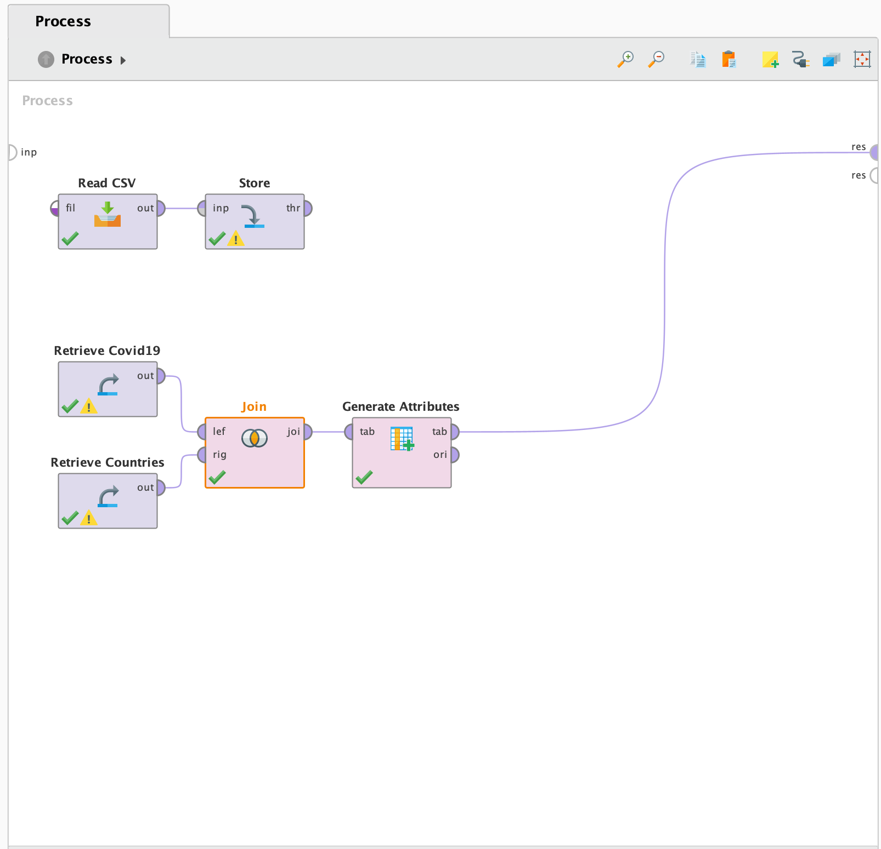

Figure 5. Replacing missing Continent values based on the secondary dataset.

## Creating some visualizations

Let’s take a look at some interesting statistics.

Firstly, let’s display the data for Poland.

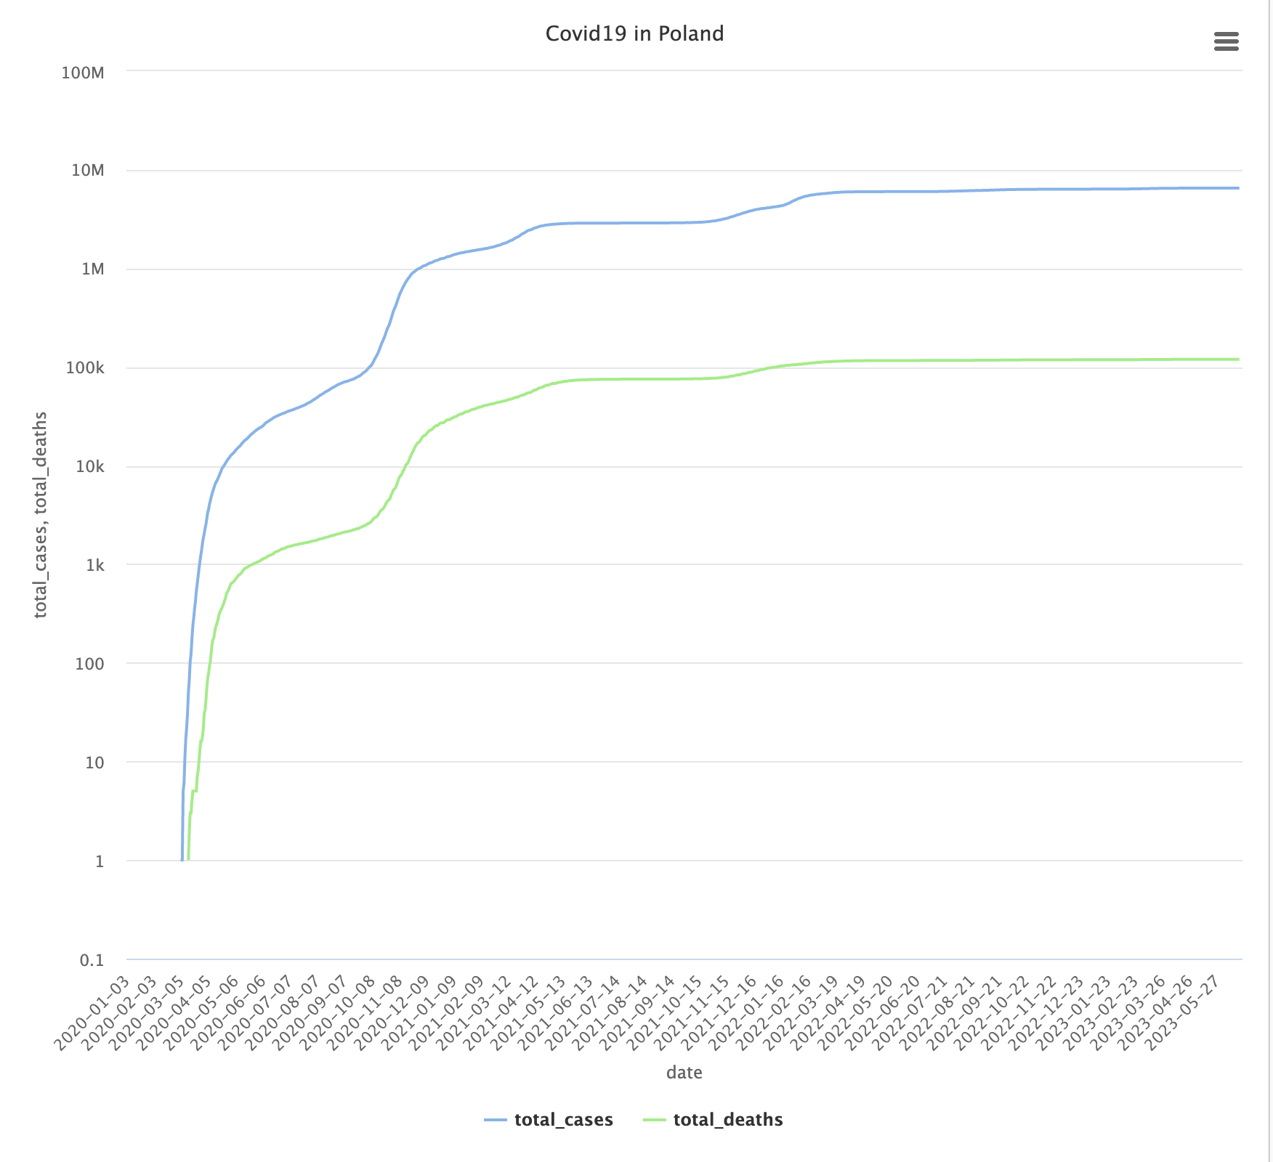

Figure 6. Covid19 statistics for the whole population in Poland. Logarithmic scale.

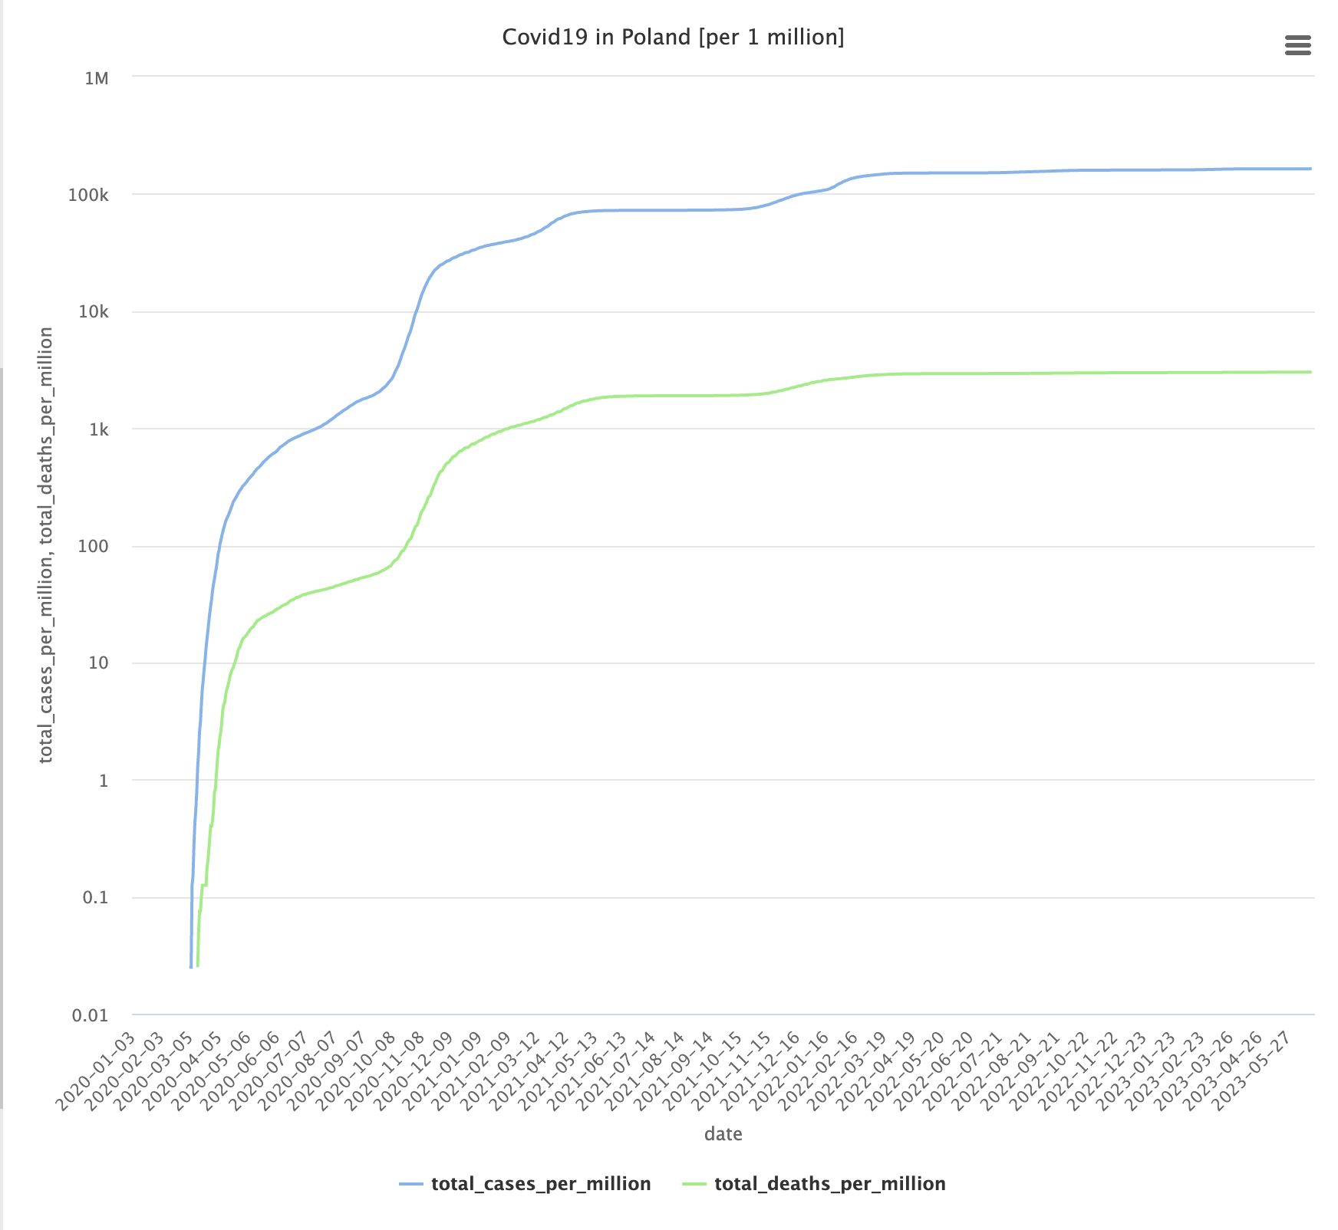

Figure 7. COVID-19 statistics per 1 million population in Poland. Logarithmic scale.

The next part of the project was done in Python.





Figure 8. The relation between number of cases and the total amount of vaccinated people in Poland, grouped by month.

The correlation between “people_vaccinated” and “new_cases” was calculated to be equal to:  
-0.13536198, which means there is a weak negative correlation between the two attributes, and as one increases, the other attribute value decreases. This however does not mean causation.



Figure 9. The relations between Covid deaths and the total number of vaccinated people in Poland, grouped by month.

The correlation for this one was calculated to be equal to:  
-0.5063519, which means there is a strong negative correlation between the two attributes.

## Analysis of Covid based on seasons

Let’s first take a look at whether the season of the year is correlated with the amount of Covid cases and deaths in Europe and the US.



Figure 10. The amount of COVID cases and deaths recorded in Europe and North America, grouped by season (1 – Winter, 2 – Spring, 3 – Summer, 4 – Autumn).

Since Covid began in early 2020, let’s exclude the first months up until December 2020.



Figure 11. The amount of COVID cases and deaths recorded in Europe and North America, grouped by season (1 – Winter, 2 – Spring, 3 – Summer, 4 – Autumn). Data from 1.12.2020 – 25.06.2023.

We can see that Winter comes with a much-increased amount of both Covid cases and Covid deaths, even if we exclude the initial few months of the pandemic.